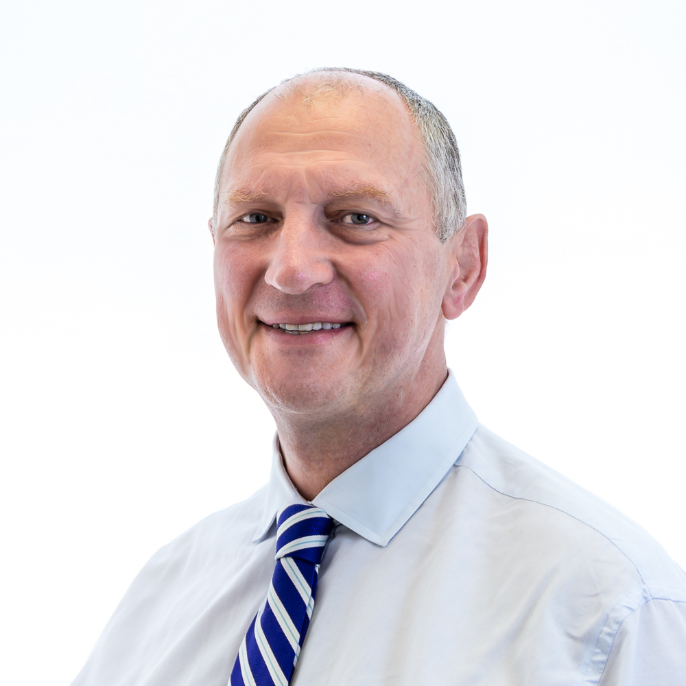

After gaining a first class honours degree in Physiology, Mr Little qualified at Cambridge University with a distinction in surgery in 1983. He then underwent specialist training in ophthalmology at Oxford, St Thomas’s and Moorfields Eye Hospital. His particular interests are cataract surgery and glaucoma. He is a consultant at Moorfields Eye Hospital, where he is responsible for running their training programme in cataract surgery. He has been performing phacoemulsification for over 20 years and he has a particular interest in complex cataract surgery. In 2010 he was listed in The Times “Top Doctors” as one of the five top ophthalmologists in Great Britain.
He runs training courses in cataract surgery in the UK, Europe and the USA and in 2009-2013 was appointed as the International Member of the Cataract Clinical Committee of the American Society of Cataract & Refractive Surgeons. He was also elected to the International Intraocular Implant Club (250 members globally) in recognition of his contribution to the development of cataract surgery. He is a Principal UK Expert on the International Working Group of the IEC/BSi that develops global standards for ophthalmic surgical equipment. In 2006 he was elected Fellow of the Higher Education Academy. He is currently President of the UK & Ireland Society of Cataract & Refractive Surgeons (UKISCRS).
He is a regular invited speaker and chairman at national and international meetings. In 2009 he received the International Ophthalmologist Education Award from the American Academy of Ophthalmology. In 2010 he was Visiting Professor in New Zealand and delivered a lecture tour encompassing their principle ophthalmology departments. In 2012 he received the Gold Medal award of the Intraocular Implant and Refractive Society of India and an Exceptional Service Award, Gold Medal in Ophthalmology from the International Academy for Advances in Ophthalmology.
In 2011 he was Visiting Professor in Iowa where he delivered the prestigious Wolfe Foundation Lecture, the first UK ophthalmologist to do so in its 42-year history. In 2014 was invited as Visiting Professor to Wills Eye Hospital in Philadelphia.
He is active in the Royal College of Ophthalmologists as a member of their Information Technology Committee, Microsurgical Training Sub-Committee, e-learning Committee and the Quality and Safety Committee.
Mr Little is involved in clinical research and has published over 50 articles in peer-reviewed journals as well as authored numerous chapters and contributed to major textbooks. He is Series Editor of the award-winning Video Atlas of Eye Surgery whose material is licensed to the American Academy of Ophthalmology and used by over half the trainee ophthalmologists in the USA (www.eyemovies.co.uk).
He has worked for ORBIS, the international eye charity, for over 15 years has been an active member of their Volunteer Faculty training eye surgeons in developing countries. He is also one of their UK Ambassadors, in which capacity he promotes ORBIS in the UK and Europe.
He was elected a Member of the Guild of Master Craftsmen for his cabinet making skills and is a keen motorcyclist. In 1985 he built his own aluminium-bodied convertible classic sports car that was used in a TV series. He has been an enthusiastic motorcyclist since he was sixteen and holds a RoSPA Gold level advanced driving licence. He lives in north London and is married to Kate, his eternally tolerant GP wife. They have three grown up children who generally find them both an embarrassment.
Private Practice
London Claremont Clinic
50-52 New Cavendish Street
London W1G 8TL
T: 0203 757 6555
F: 0203 700 4042
E: info@londoncavendishcentre.co.uk
W: www.londonclaremontclinic.co.uk
NHS Practice
Moorfields Eye Hospital NHS Foundation Trust
162 City Road
London EC1V 2PD
T: +44 (0)20 7253 3411
T: +44 (0)20 7566 2018 (direct)
E: brian.little@moorfields.nhs.uk

